Ideation Phase: Empathy Map Canvas
C) Empathy Map Canvas
The Empathy Map helps understand the requirements of primary stakeholders (EV buyers, fleet managers, infrastructure planners):

Empathy Map Layout Diagram
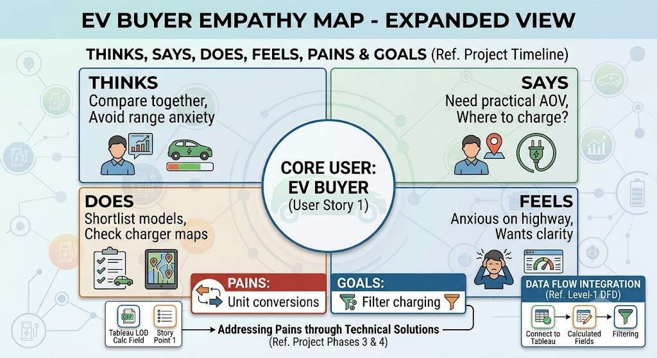

Ideation Phase Summary
The Ideation Phase established selection parameters, identified the primary target as an interactive dashboard, and outlined structured empathy mapping for user personas. This guiding framework shapes the data modeling and visualization layers.

User Persona Profile Reference
Section | Details
Says | "I want an EV that fits my budget and provides practical range. I also need to understand charging availability."
Thinks | "Range, efficiency, charging speed, price, and infrastructure should be compared together rather than in separate sources."
Does | Compares brands, models, prices, range, acceleration, top speed, charging capability, and charging locations.
Feels | Uncertain when specifications use different units or when infrastructure information is difficult to interpret.
Pain Points | Scattered data files, unit discrepancies (e.g. km vs miles, dollars vs rupees), lack of interactive maps.
Goals | Confirm a vehicle purchase shortlist, analyze charger network gaps, and evaluate fleet efficiency.
Visual Reference: EV Charging Station Map Concept


